Chapter 11, Solution 60.

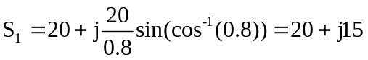
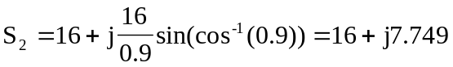

But 